# **CS370: Assignment 2 - Documentation**

**Family Name:** Goh

**First Name :** Wei Zhe

**Email id : weizhe.goh@digipen.edu**

_________________________________________________________________________

Declaration:

I hereby declare that I adhere to the Academic Integrity Policy stated in the syllabus document. In addition, I also declare that the output images shown in this document are solely taken from the project that I have implemented for this assignment and the same output image will be generated when run in any Digipen PCs using the submitted project.



_________________________________________________________________________

# **Load Image:**

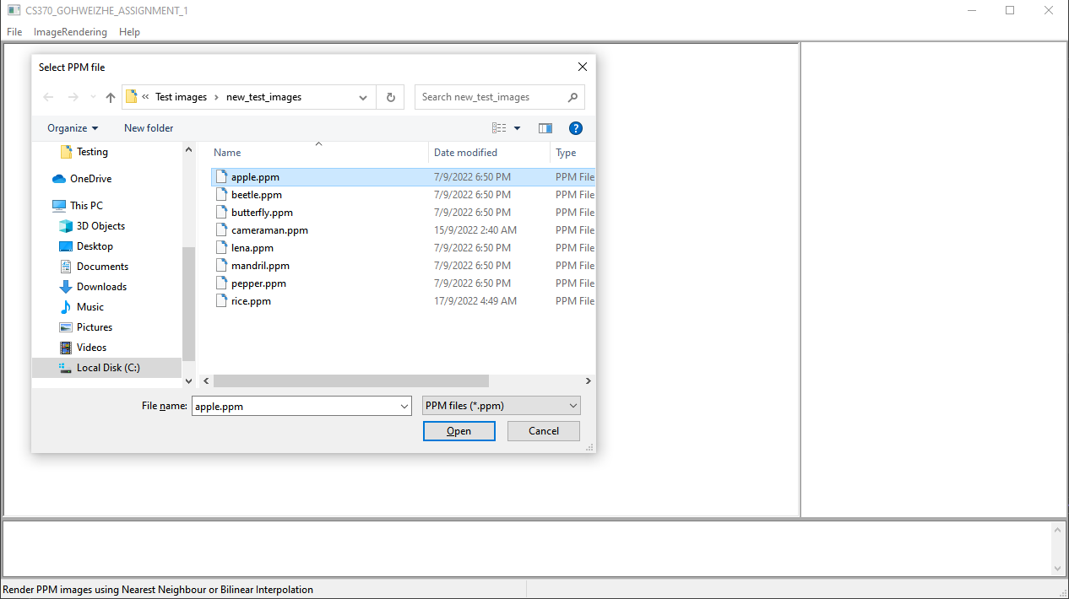

File Dialog pops up for users to select the image that they want to load.

# **Display Image on Screen:**

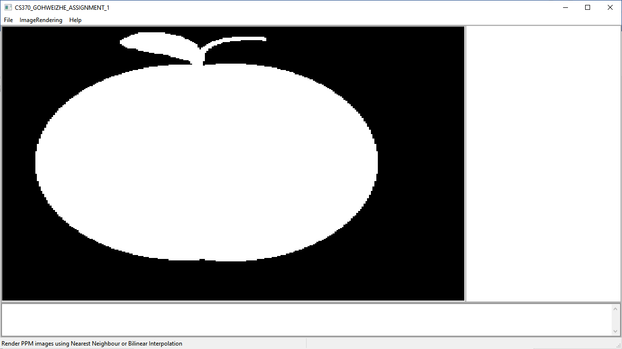

# **Save Image (Before):**

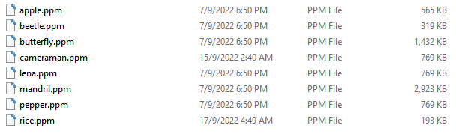

# **Save Image (After):**

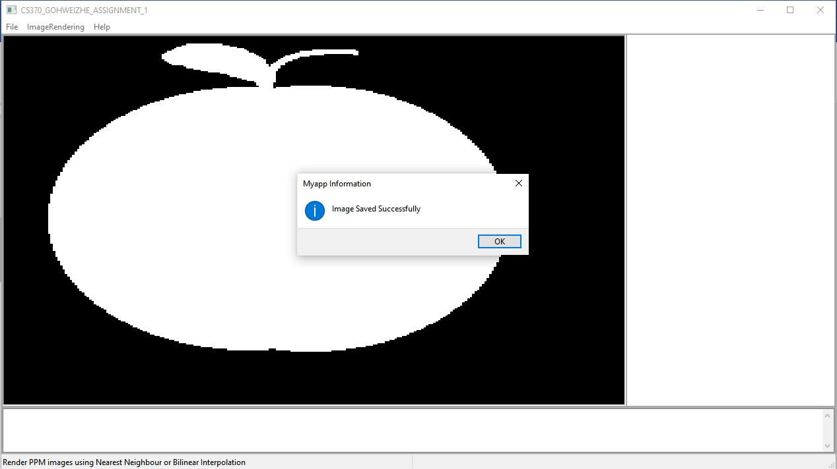

Message pops up “Image Saved Successfully.” to indicate image as been saved successfully.

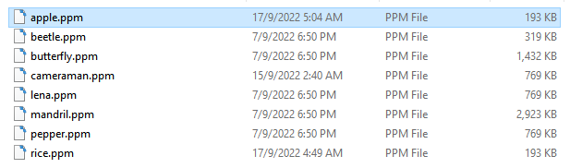

The time of apple.ppm is being updated when saved.

# **Save As Image:**

# 

File dialog pops up for users to input their file name.

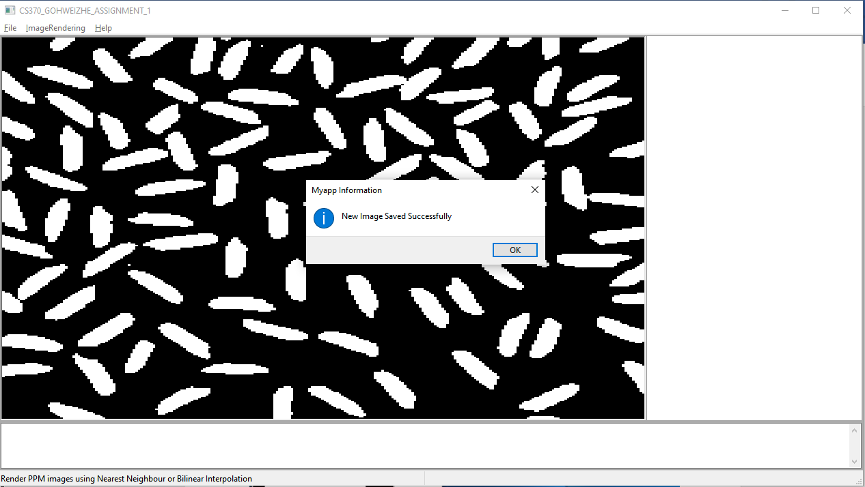

Message pops up “New image saved successfully.” to indicate a new image as been saved successfully.

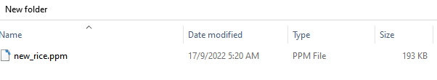

# **Image scaled to match client window at all times:**

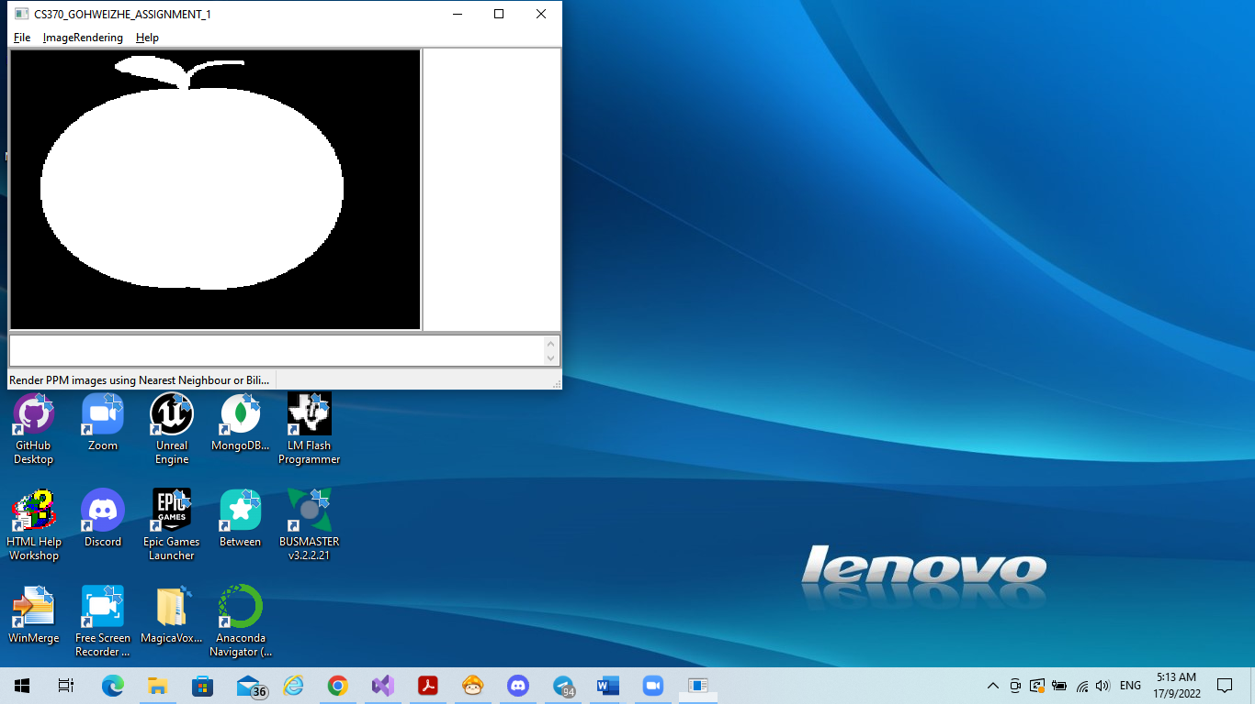

# **Nearest Neighbor Interpolation:**

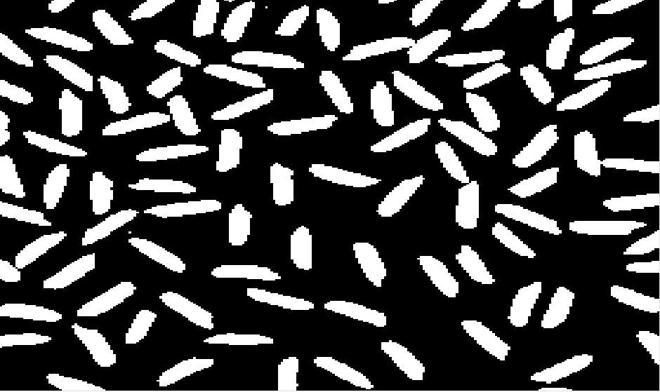

# **Bilinear Interpolation:**

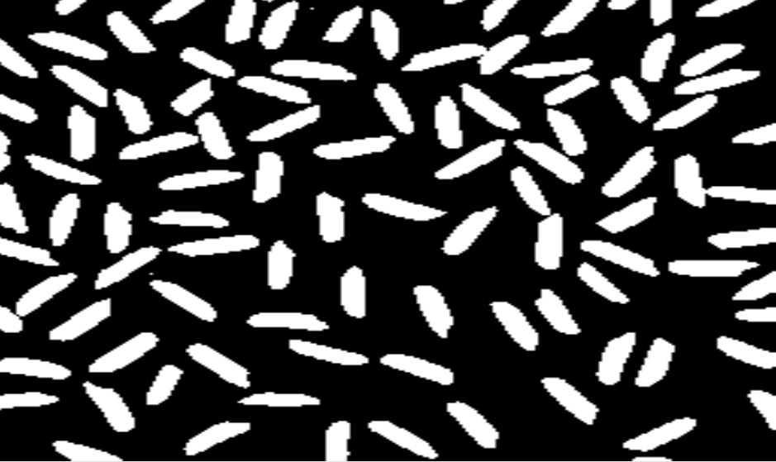

# **Bicubic Interpolation:**

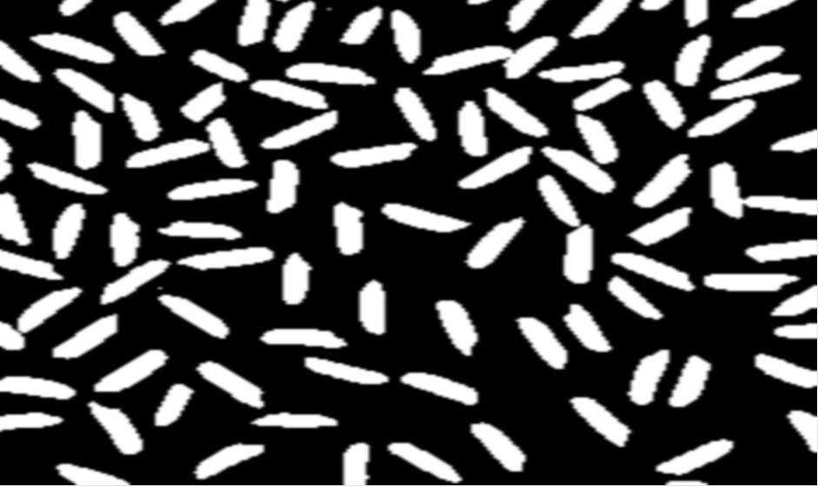

# **Addition**

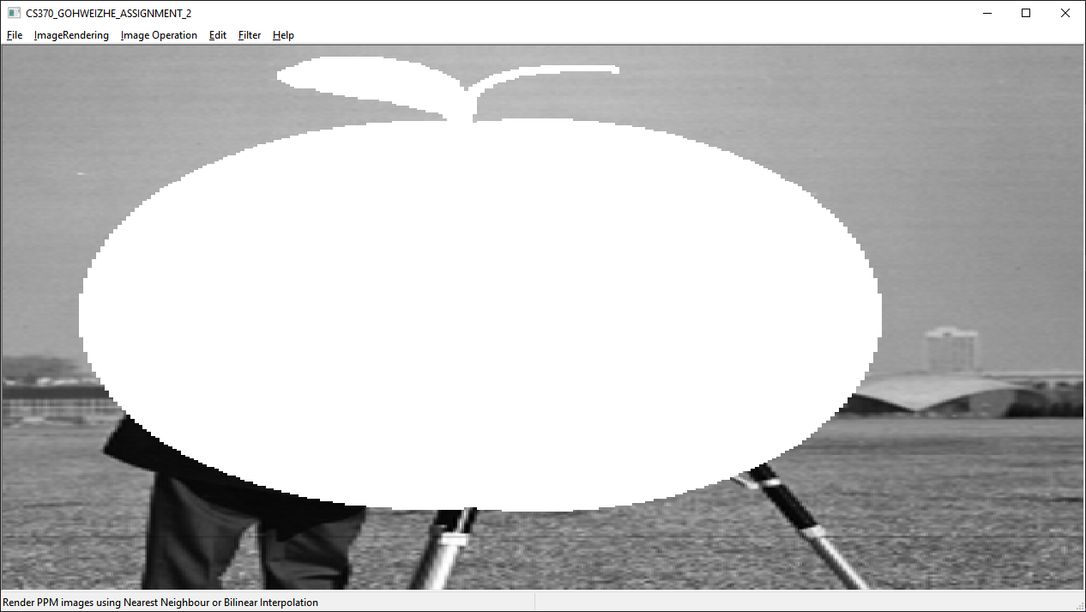

Cameraman (Image 1) + Apple (Image 2)

**Steps to generate image addition:**

File Menu > Open Image 1 (Cameraman) > Open Image 2 (Apple) > Image Operation Menu > Addition.

# **Subtraction**

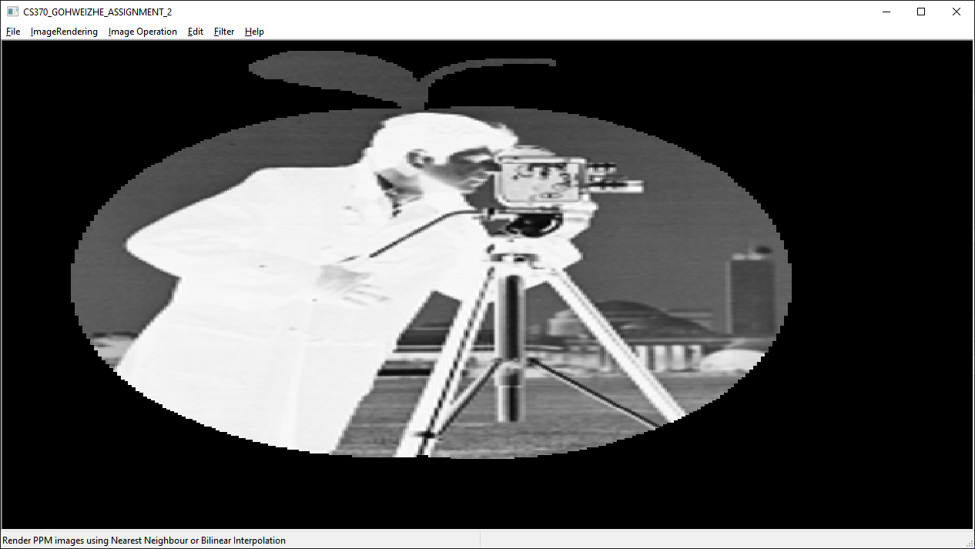

Cameraman (Image 1) - Apple (Image 2)

**Steps to generate image subtraction:**

File Menu > Open Image 1 (Cameraman) > Open Image 2 (Apple) > Image Operation Menu > Subtraction.

# **Product**

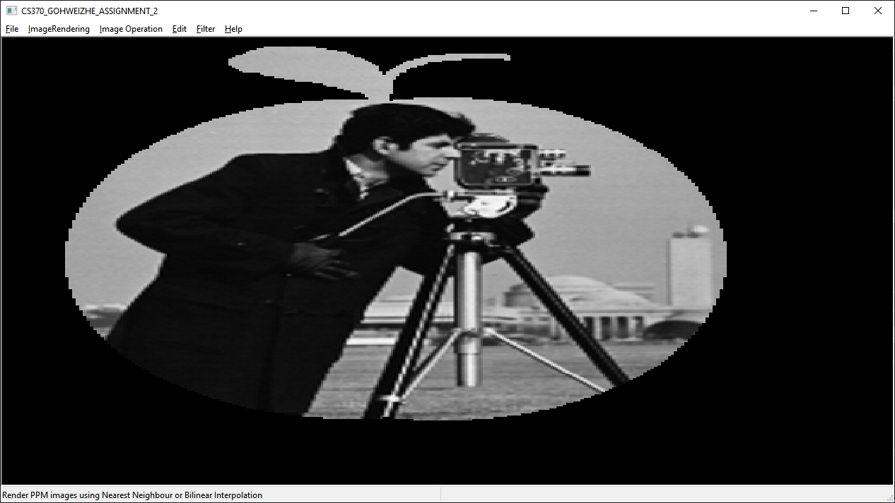

Cameraman (Image 1) * Apple (Image 2)

**Steps to generate image multiply:**

File Menu > Open Image 1 (Cameraman) > Open Image 2 (Apple) > Image Operation Menu > Multiply.

# **Division**

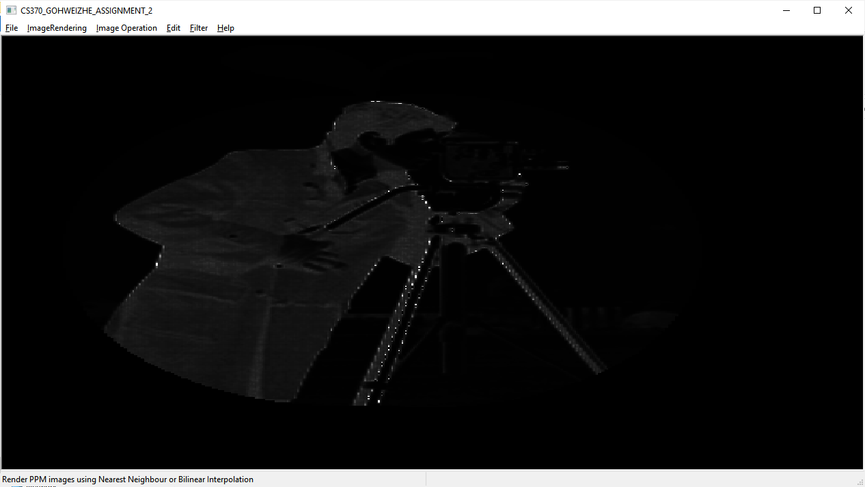

Cameraman (Image 1) / Apple (Image 2)

**Steps to generate image division:**

File Menu > Open Image 1 (Cameraman) > Open Image 2 (Apple) > Image Operation Menu > Division.

# **Negative**

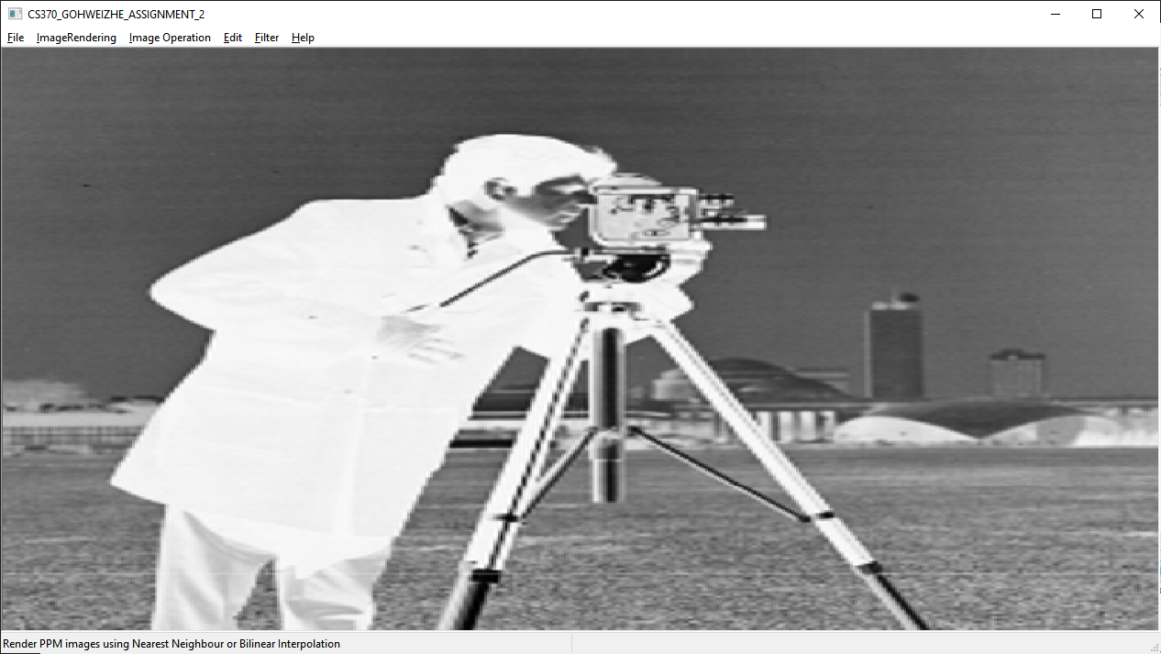

**Steps to generate image negative:**

File Menu > Open Image (Cameraman) > Edit Menu > Image Negative.

# **Log Transform**

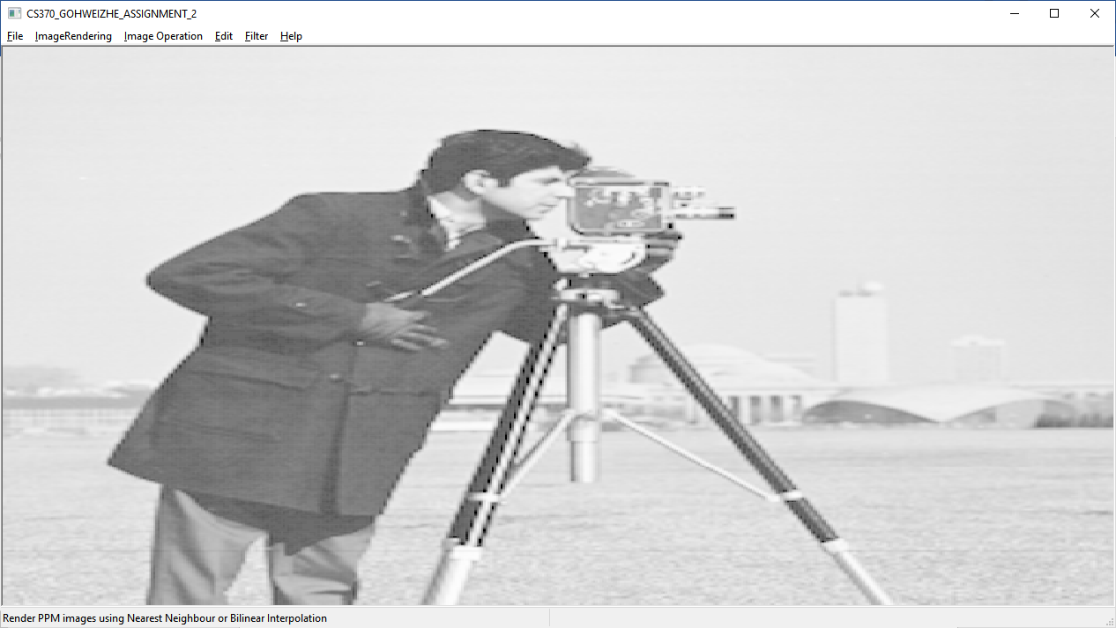

Log transform generated with constant value = 105.00f

**Steps to generate image log transform:**

File Menu > Open Image (Cameraman) > Edit Menu > Log Transform.

# **Power (Gamma) Transform**

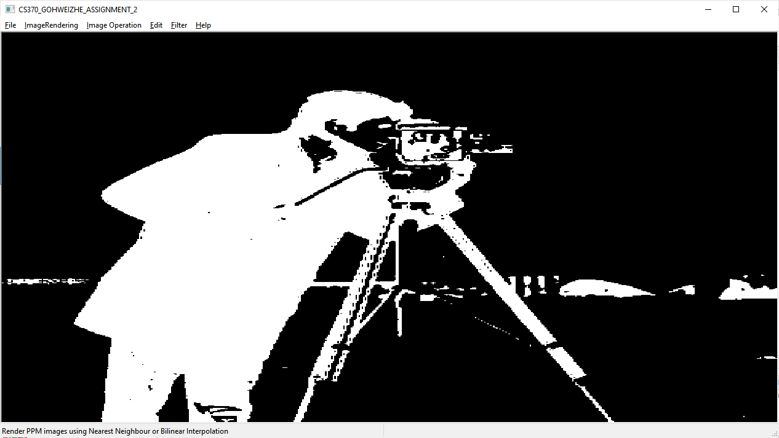

Gamma transform generated with constant value = 2.00f, Gamma = 5.00f

**Steps to generate image gamma transform:**

File Menu > Open Image (Cameraman) > Edit Menu > Gamma Transform.

# **Histogram Equalization**

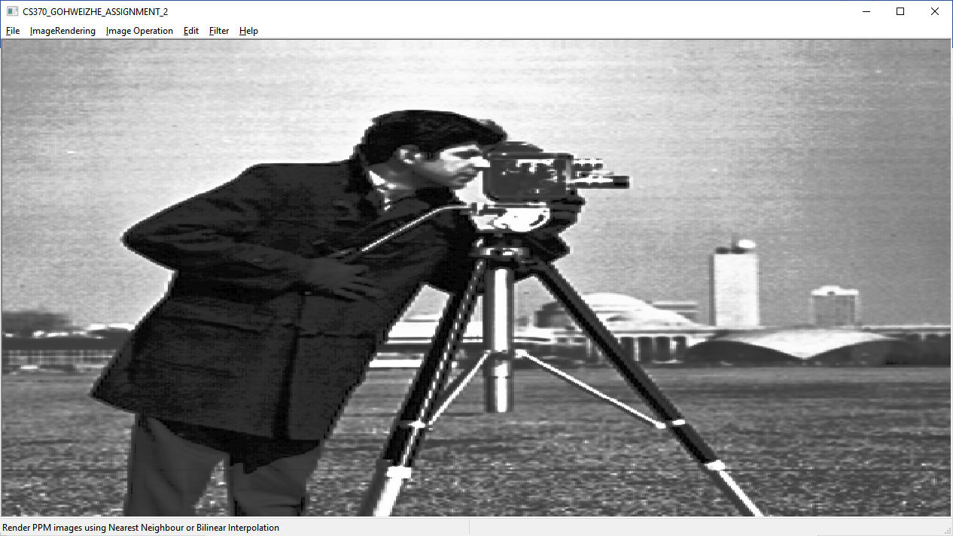

**Steps to generate image histogram equalization:**

File Menu > Open Image (Cameraman) > Edit Menu > Histogram Equalization

# **Gaussian Filter**

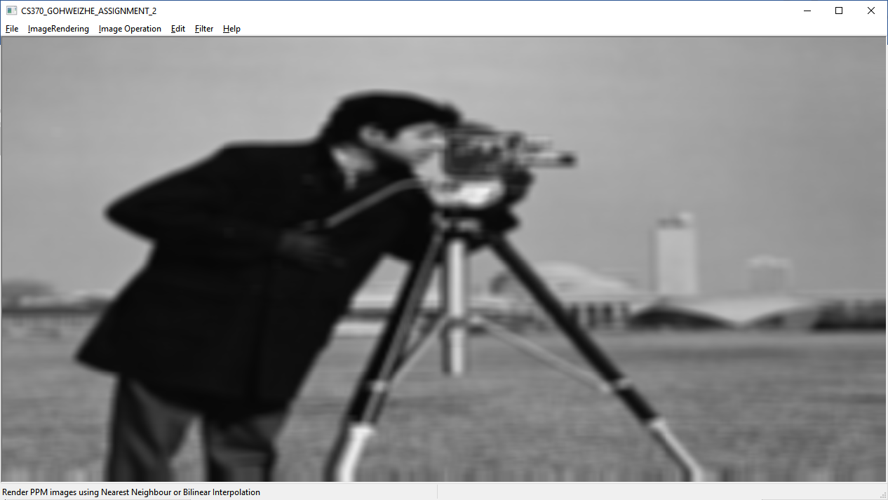

Gaussian Filter generated with Kernel = 7, Sigma = 10.0f

**Steps to generate image – Gaussian Filter:**

File Menu > Open Image (Cameraman) > Filter > Gaussian Blur Filter

**Sobel Operator**

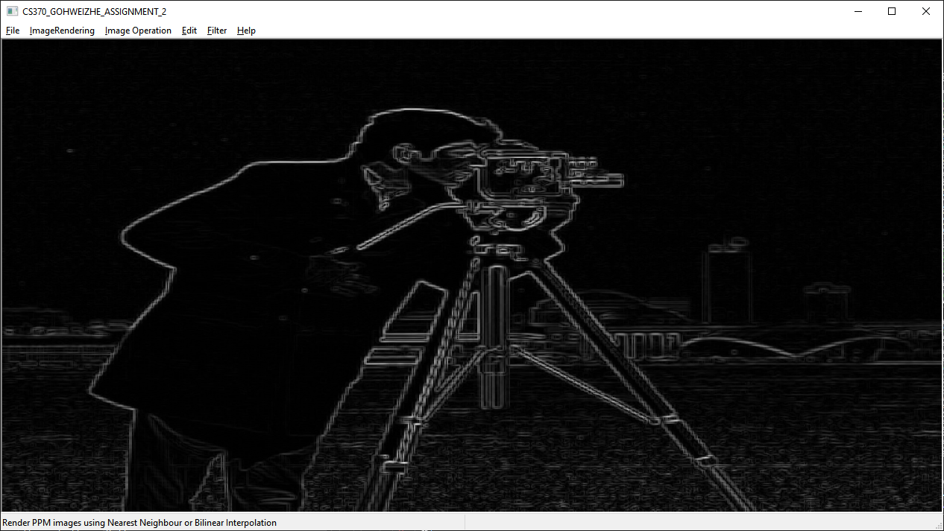

**Steps to generate image - Sobel Operator:**

File Menu > Open Image (Cameraman) > Filter > Sobel Edge Detection